**PART A**

(Part A: TO BE REFFERED BY STUDENTS)

**A.1 AIM:**

Develop a web based Mini Project

**A.2 Pre requisite:**

Basic Knowledge of HTML, CSS, JavaScript, Server-Side Scripting, jQuery, Bootstrap, PHP, Browser.

**A.3 Outcome:**

After successful completion of this experiment students will be able to:

1. Design a website using various web programming languages learnt.

**A.4 Theory:**

A mini project is desirable to be completed by a group of two or three students that cover

following tools.

HTML

DHTML

CSS

Java Script PHP

Bootstrap

jQuery

**A.5 Procedure/Task:**

1. Develop a website using Web technologies learnt.
2. The site should be attractive & interactive.
3. Prepare the document. Save and close the file and name it as RollNo._MiniProject.

**PART B**

(PART B: TO BE COMPLETED BY STUDENTS)

(Students must submit the soft copy as per following segments within two hours of the practical. The soft copy must be uploaded on the Blackboard or emailed to the concerned lab in charge faculties at the end of the practical in case the there is no Black board access available)

|  |  |
| --- | --- |
| Roll No.: **C106, C116, C121** | Name: **Mohd Amanullah Sayyed (C106)**  **Ujwala Chinta (C116)**  **Kashif Shaikh (C121)** |
| Class: C | Batch: C2 |
| Date of Experiment: 07/11/24 | Date/Time of Submission: 07/11/24 |
| Grade: |  |

**B.1 Project Details**

*(Detailed description of project. It should include answers to following questions)*

***1) Motivation to take the proposed project***

*Our motivation for choosing to develop an airline website stemmed from the desire to create something both challenging and highly relevant. Flight booking platforms are essential in today’s world, and designing one allowed us to address a real-world need. Through this project, we are gaining experience in managing complex data and delivering a smooth, user-friendly interface. It also provided an opportunity to dive into backend systems and design critical features such as search, booking, and tracking—components that make these platforms reliable and convenient for travelers. Ultimately, this project allows us to bridge theoretical learning with practical skills, preparing us for real industry challenges.*

***2) Scope of the project***

*Our airline booking website project focuses on creating a secure, user-friendly platform that allows users to register, search flights, book tickets, and complete payments with ease. Key features include a responsive design, secure payment gateway, and robust backend management to handle flight data, bookings, and user information efficiently. This project aims to simulate a real-world booking experience, delivering convenience, reliability, and scalability for future enhancements.*

***3) Working of project***

* *Users enter travel details and search for flights.*
* *Available flight options are displayed based on user input.*
* *Users select a flight and proceed to payment.*
* *Payment is processed, and booking confirmation is shown.*

***4) Advantages & disadvantages of project***

*Advantages*

* ***Time-saving and User-friendly****: Quick and efficient booking without queues.*
* ***Cost-efficient Operations****: Streamlined processes reduce operational costs.*
* ***Enhanced Data Accuracy****: Automated data entry reduces human errors.*

*Disadvantages*

* ***High Initial Investment****: Significant financial resources required for development.*
* ***Vulnerability to Cyber Threats****: Risk of data breaches and security threats.*
* ***Internet Reliance****: Limited access for users with poor internet connectivity.*

***5) Technologies used for developing the project***

*- HTML, CSS, JavaScript, Bootstrap, jQuery, Themify Icons,* *Font Awesome.*

*- Development Tools: VS Code, XAMPP, Google Fonts.*

**B.2 Output:**

**Page 1- ( Homepage)**

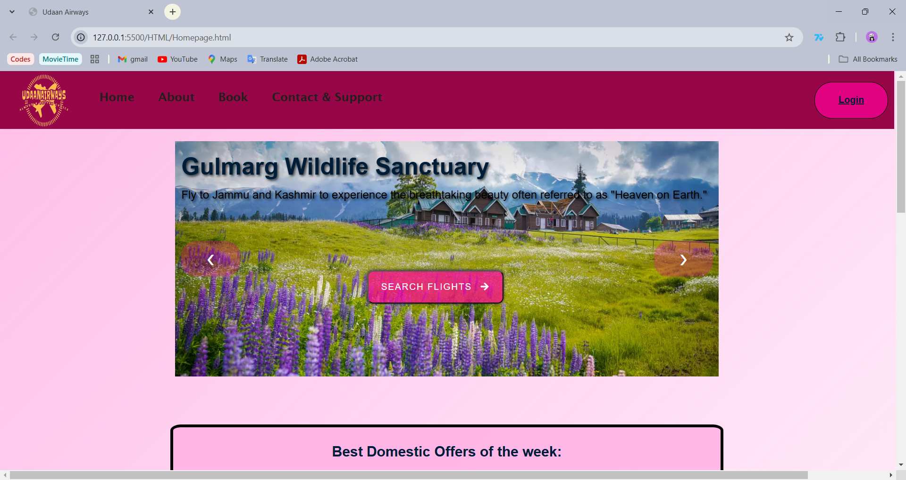

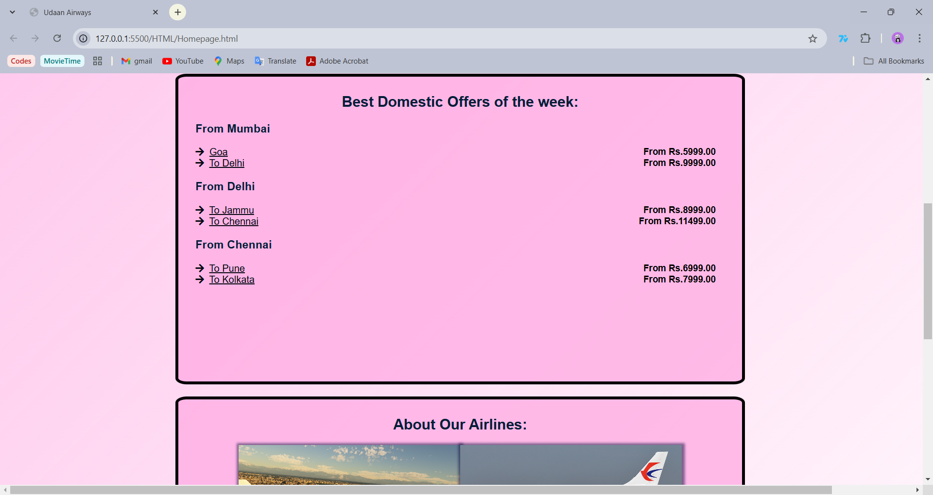

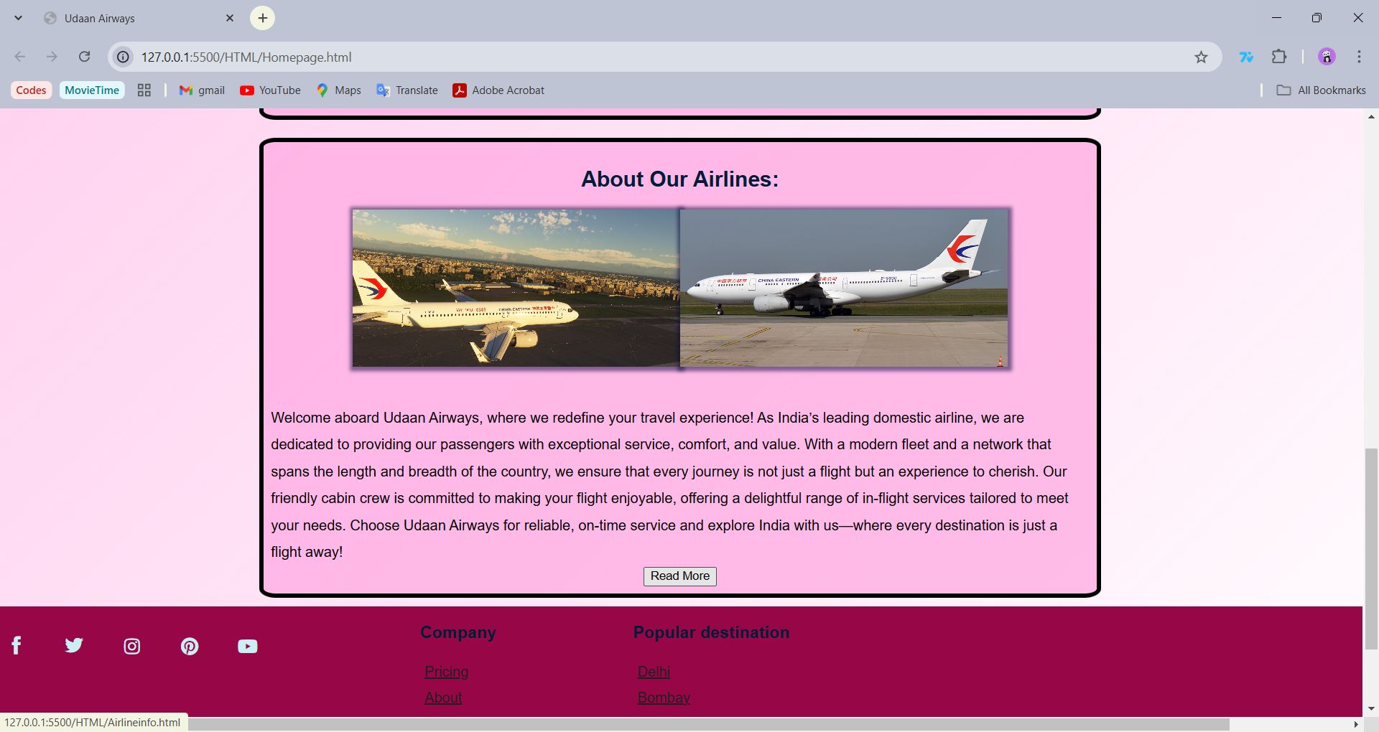

**PAGE 2- (AirlineInfo)**

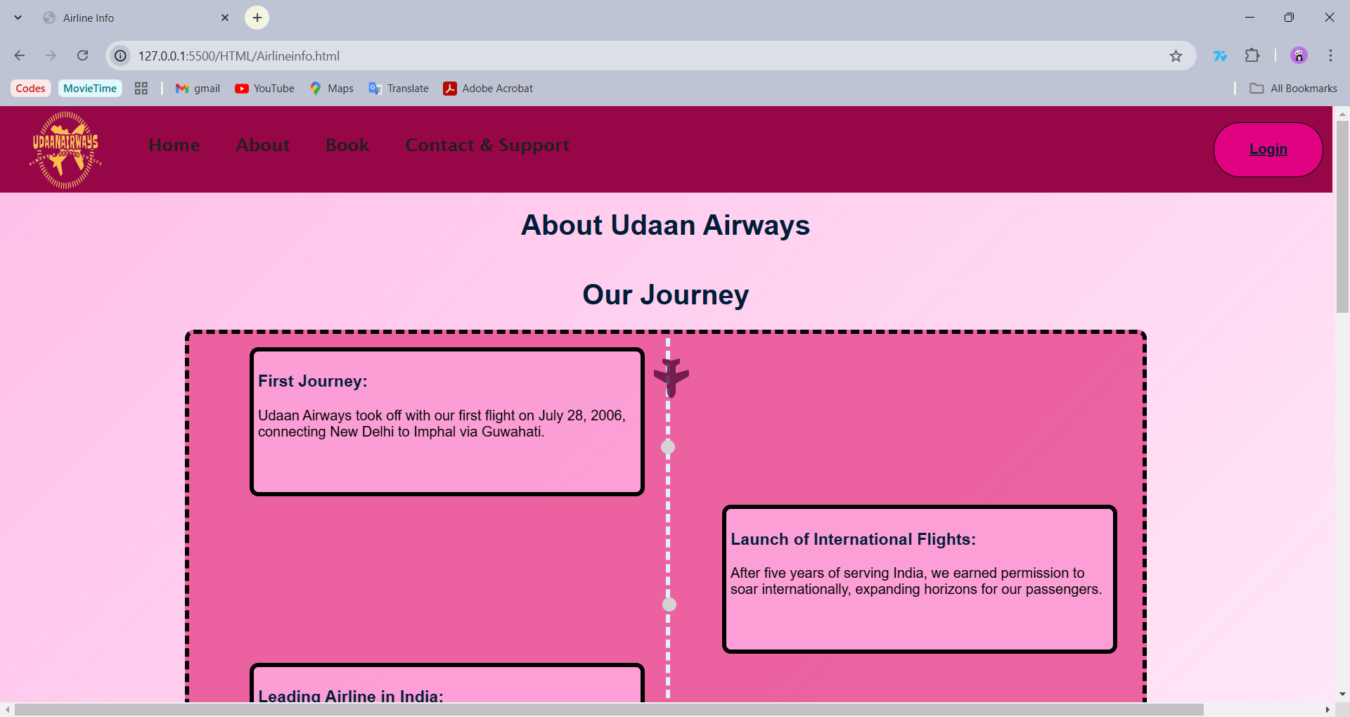

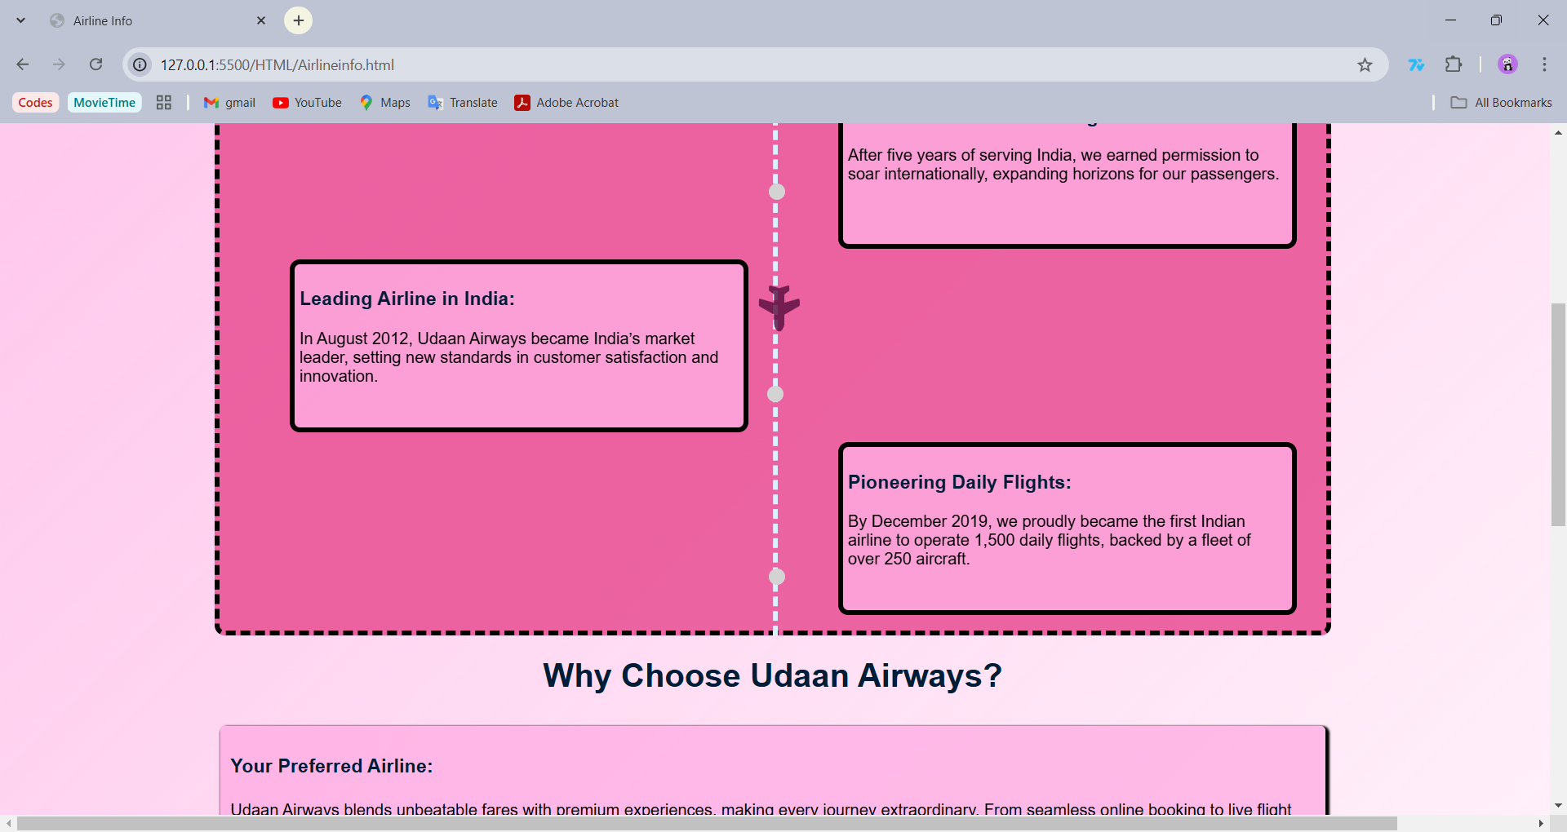

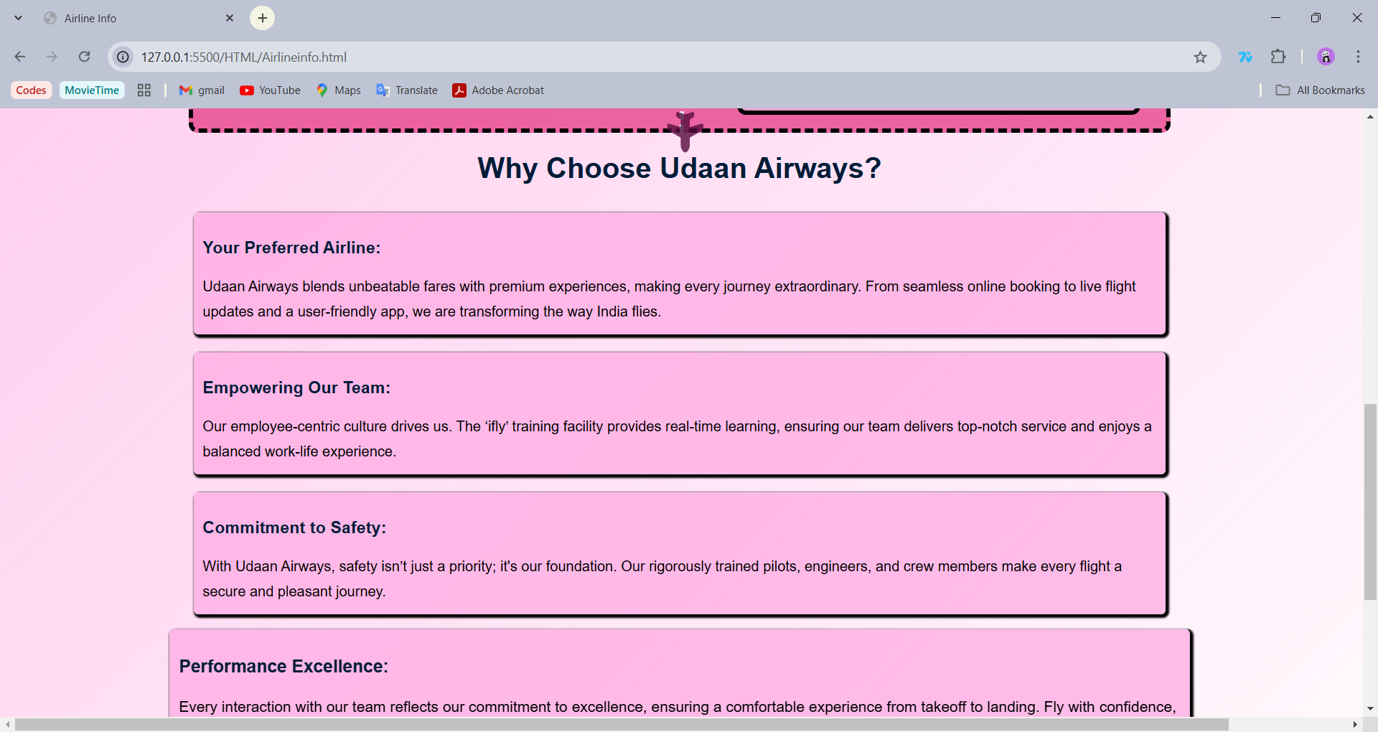

**Page 3- Register and Login**

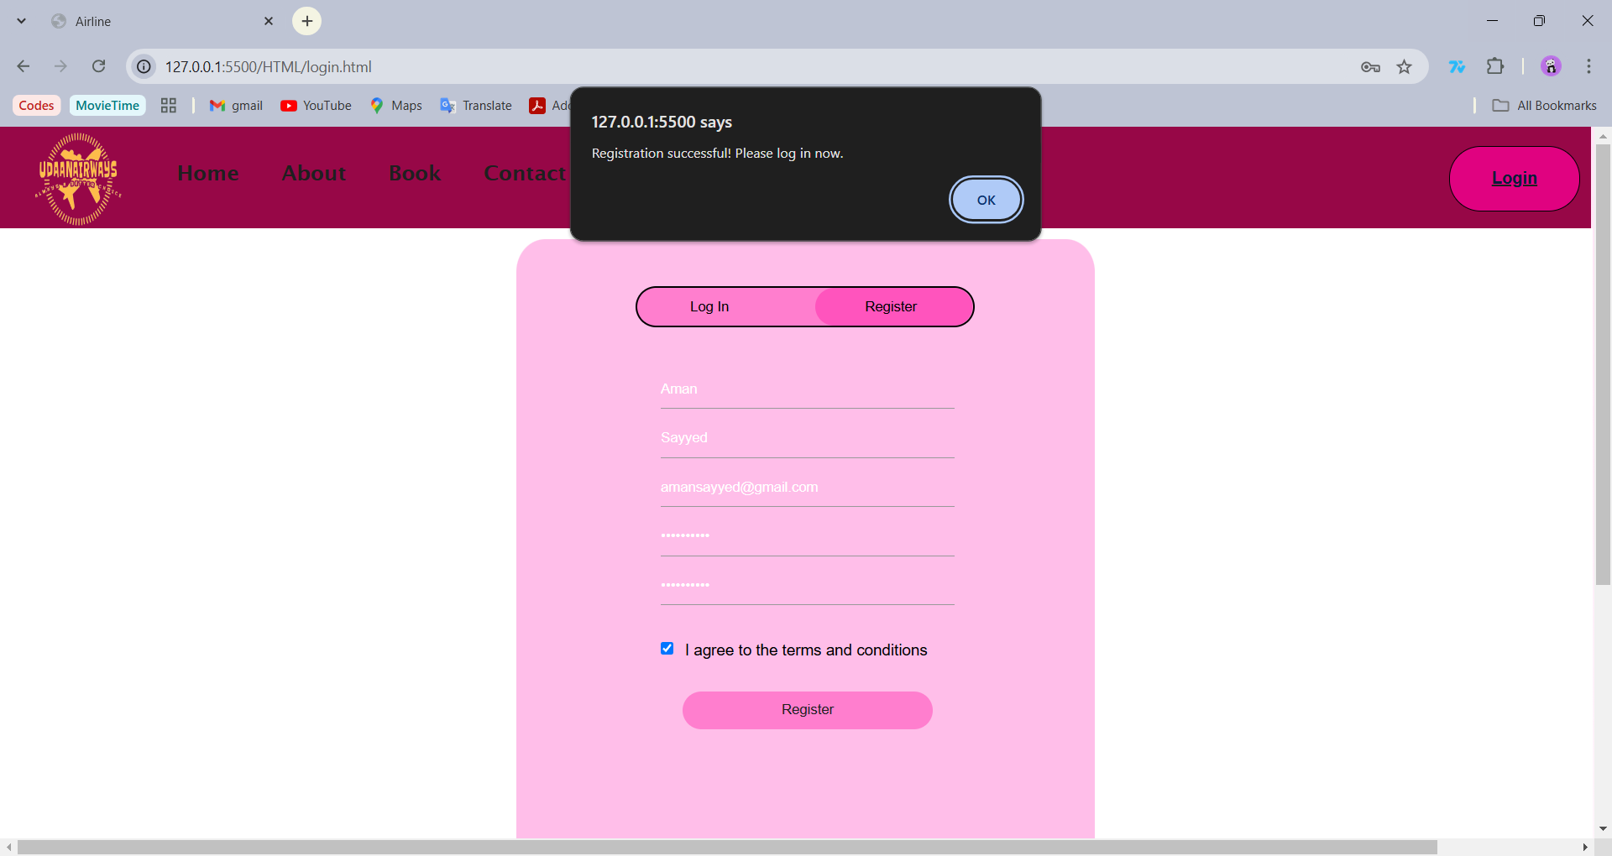

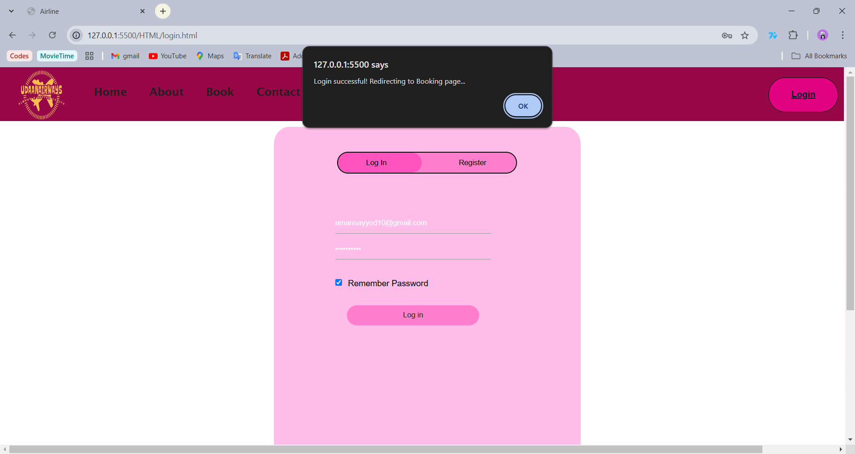

**Page 4-8 (Booking)**

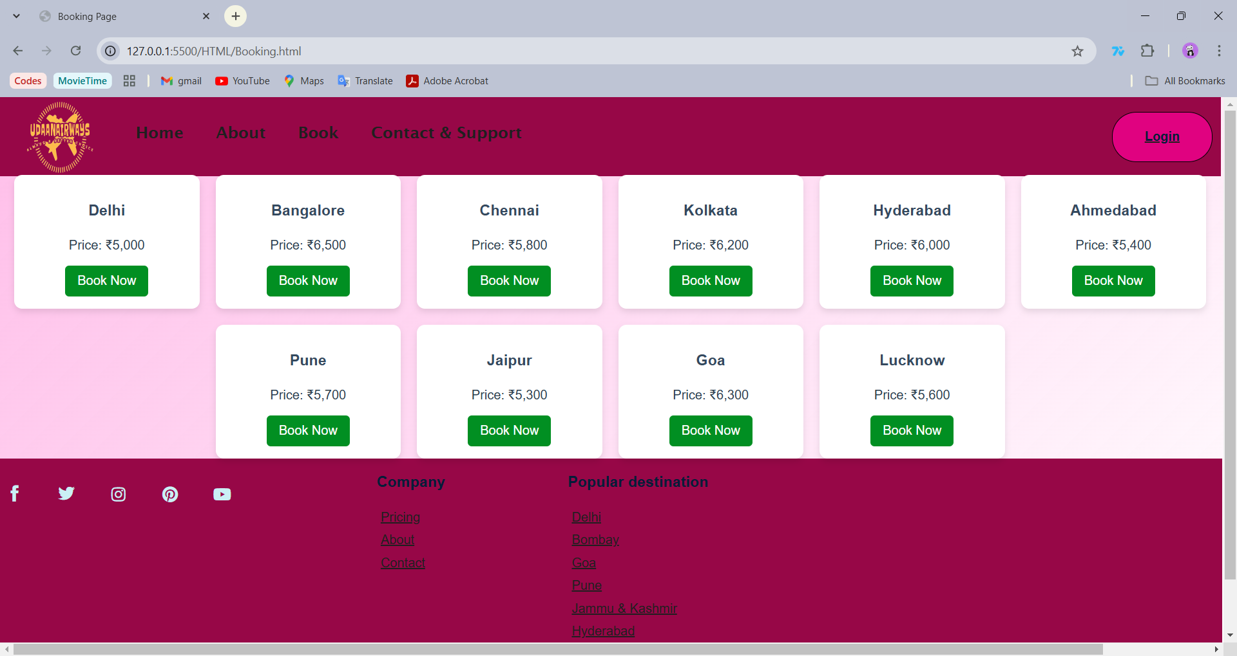

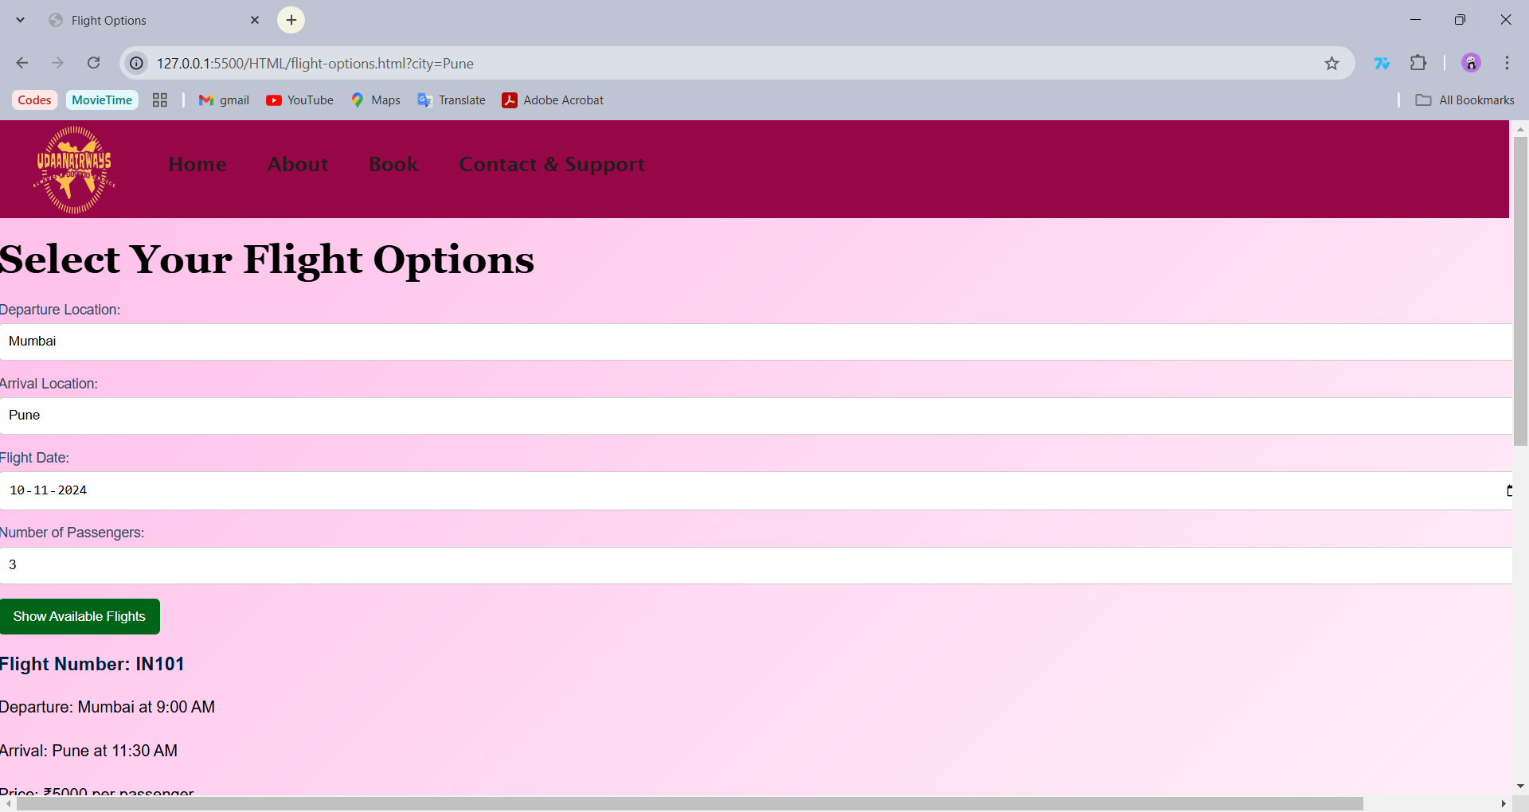

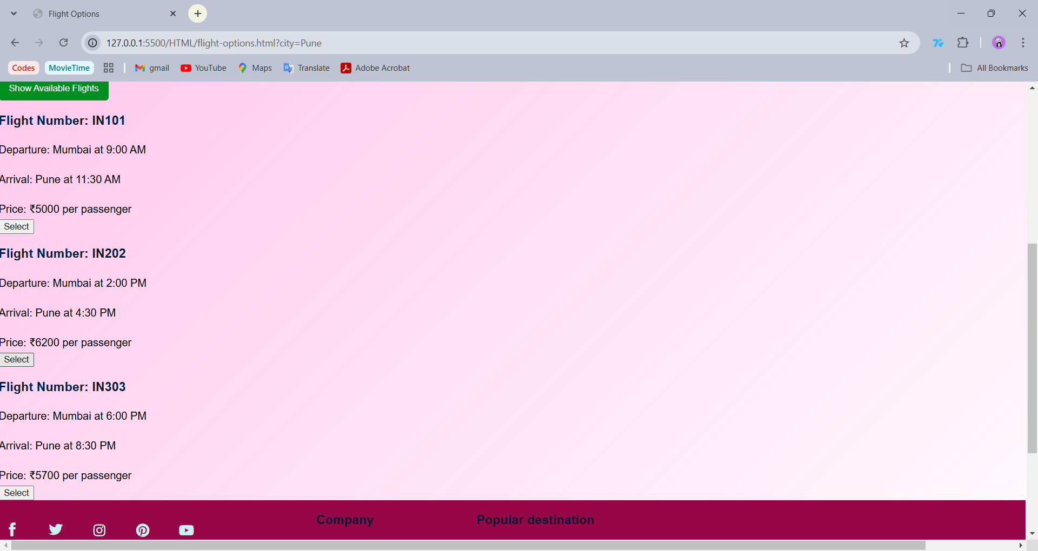

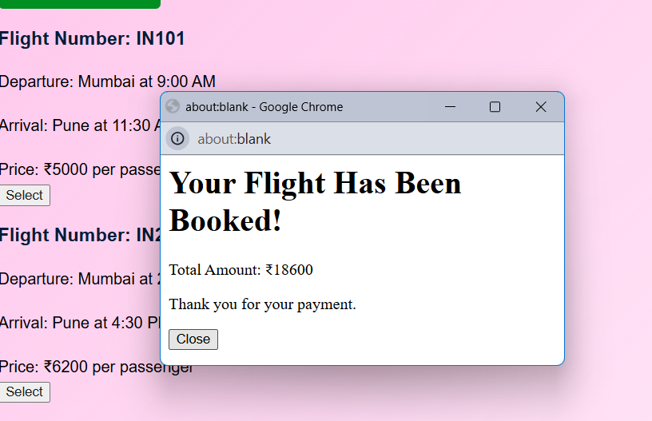

**Page 9- 15 (Customer Services)**

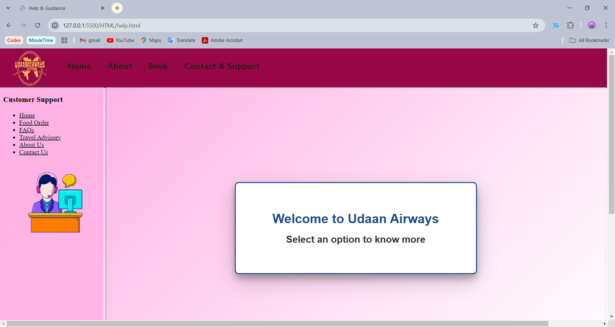

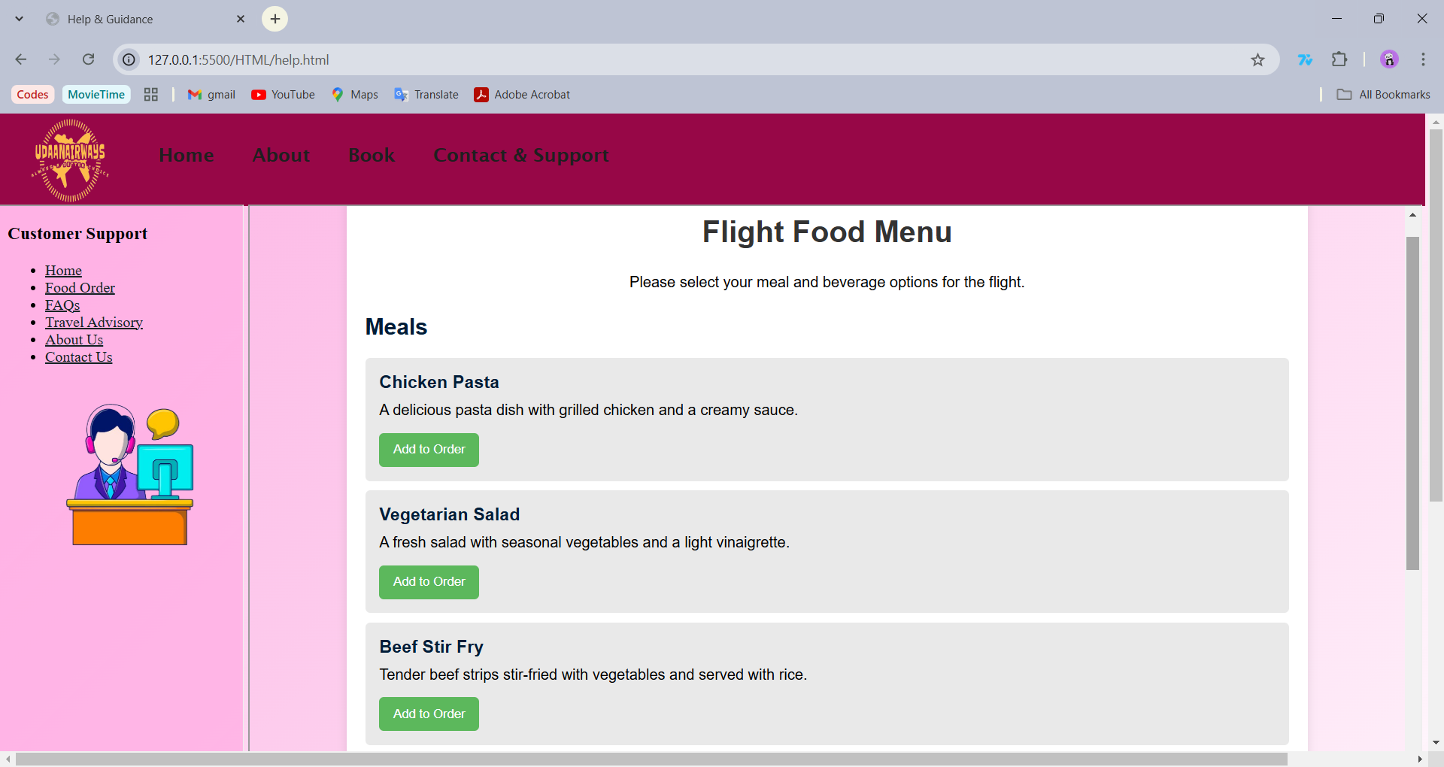

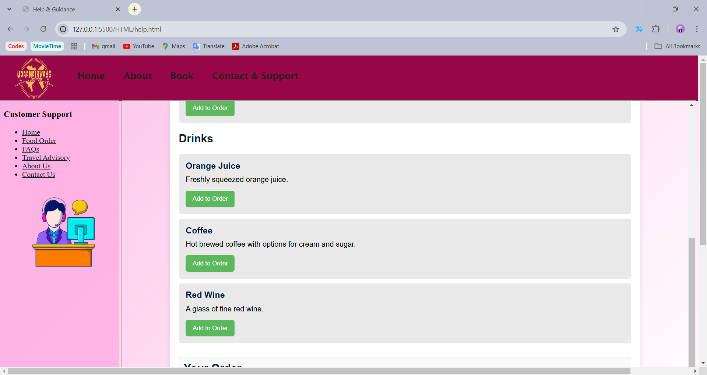

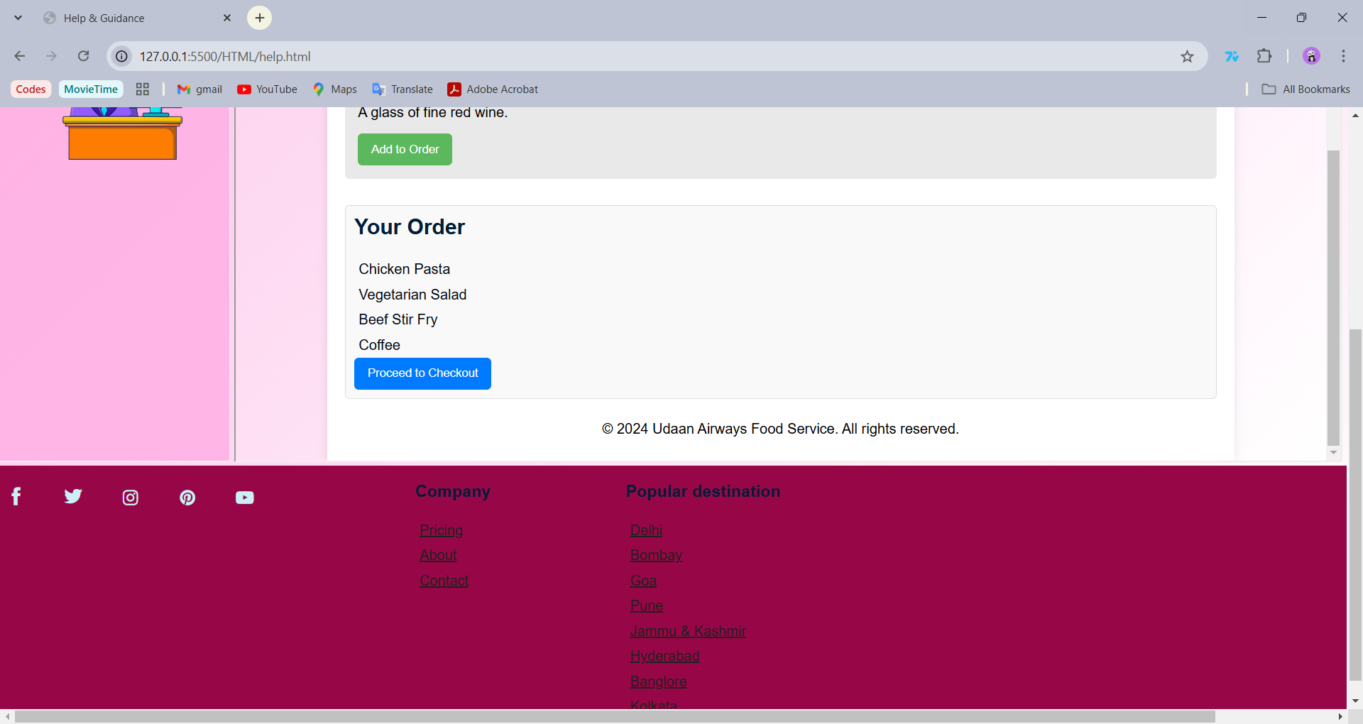

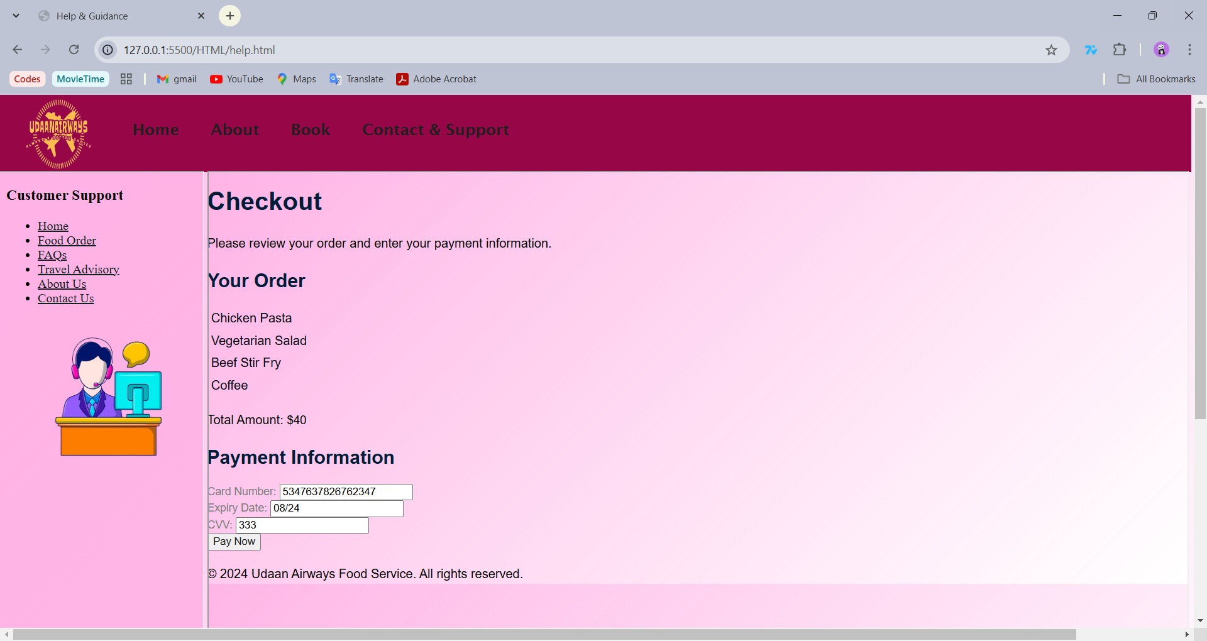

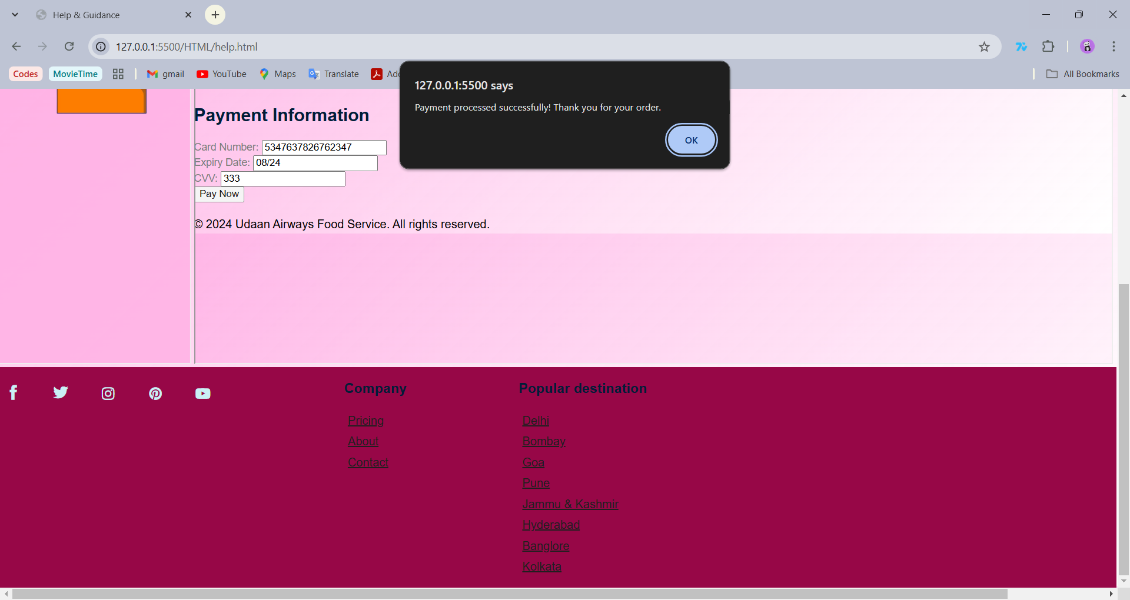

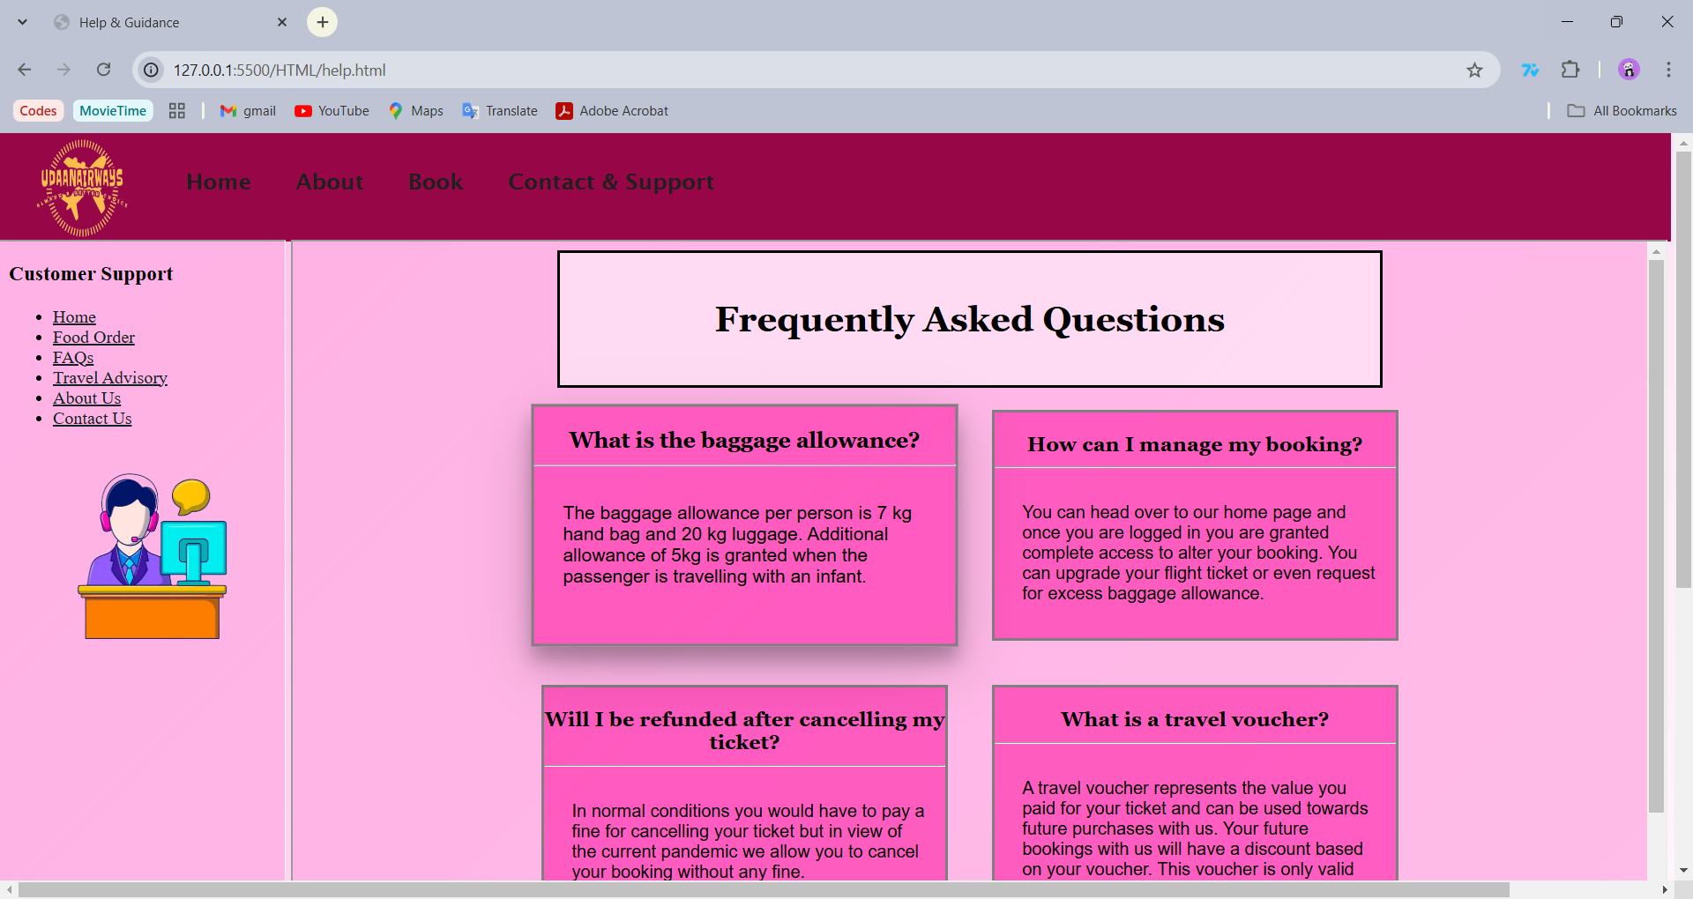

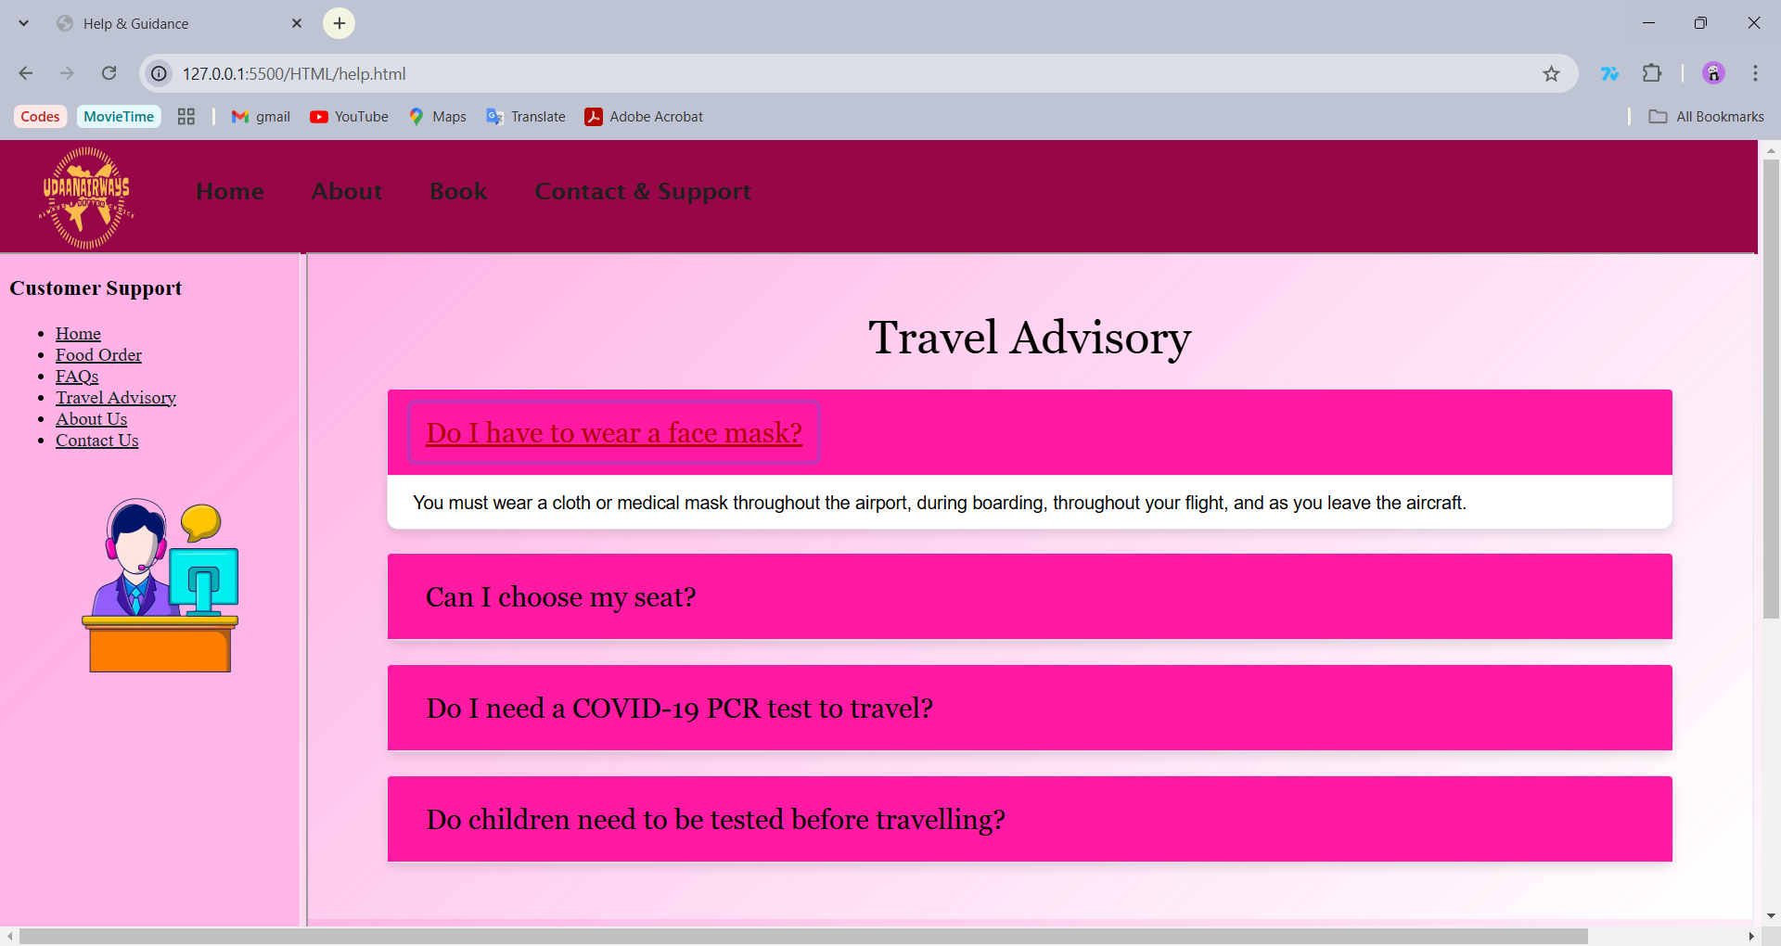

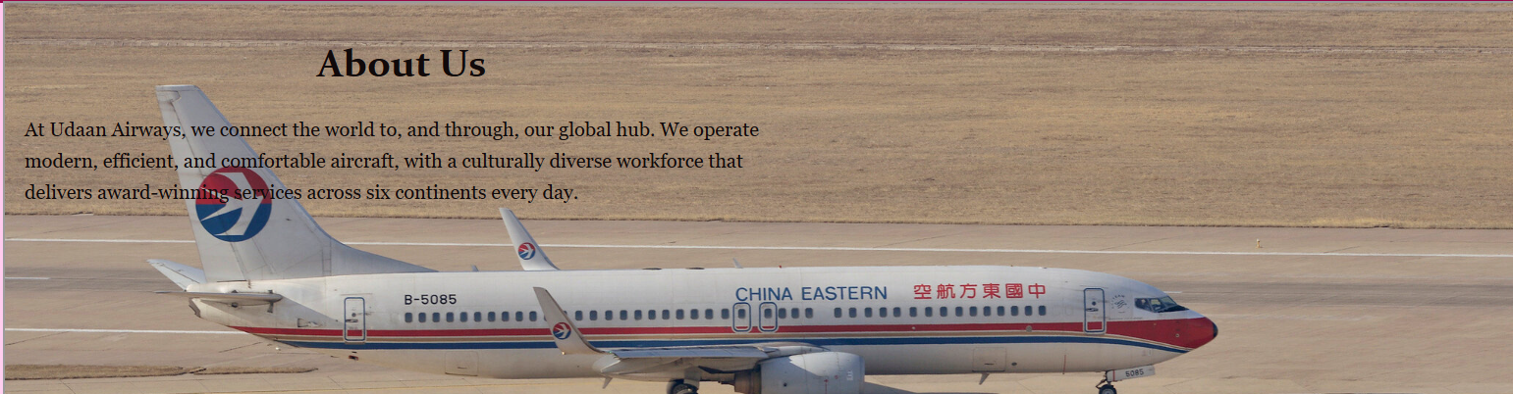

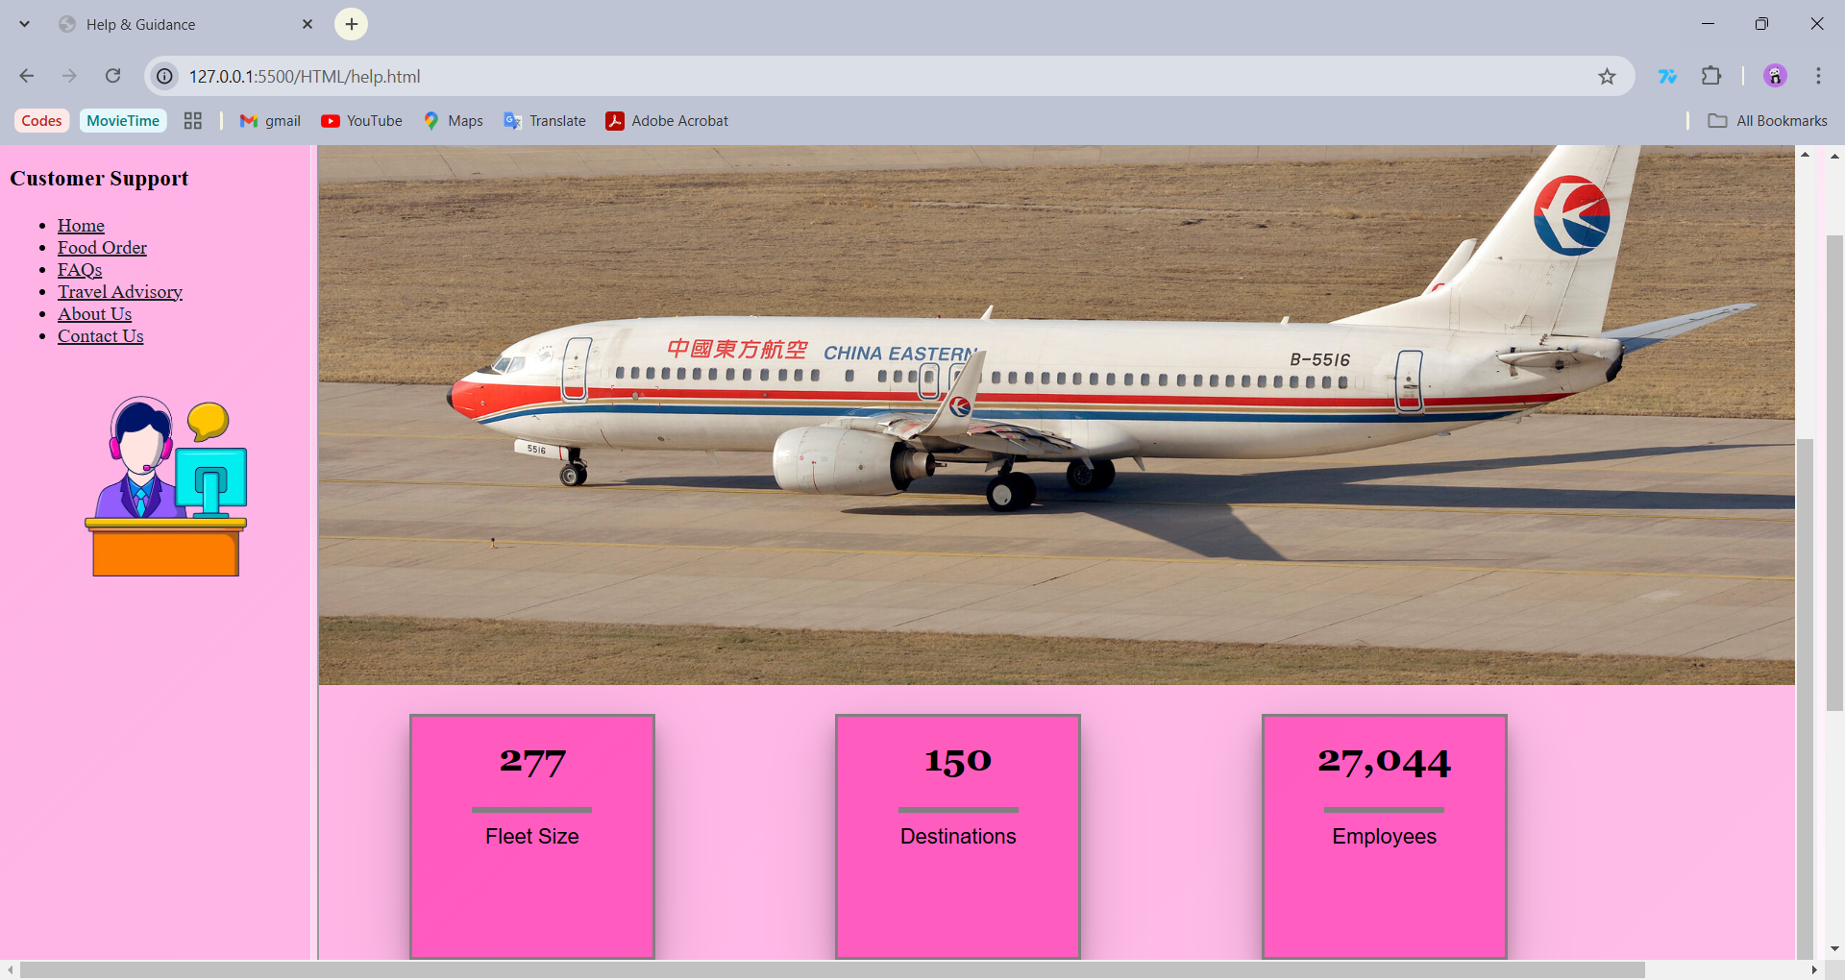

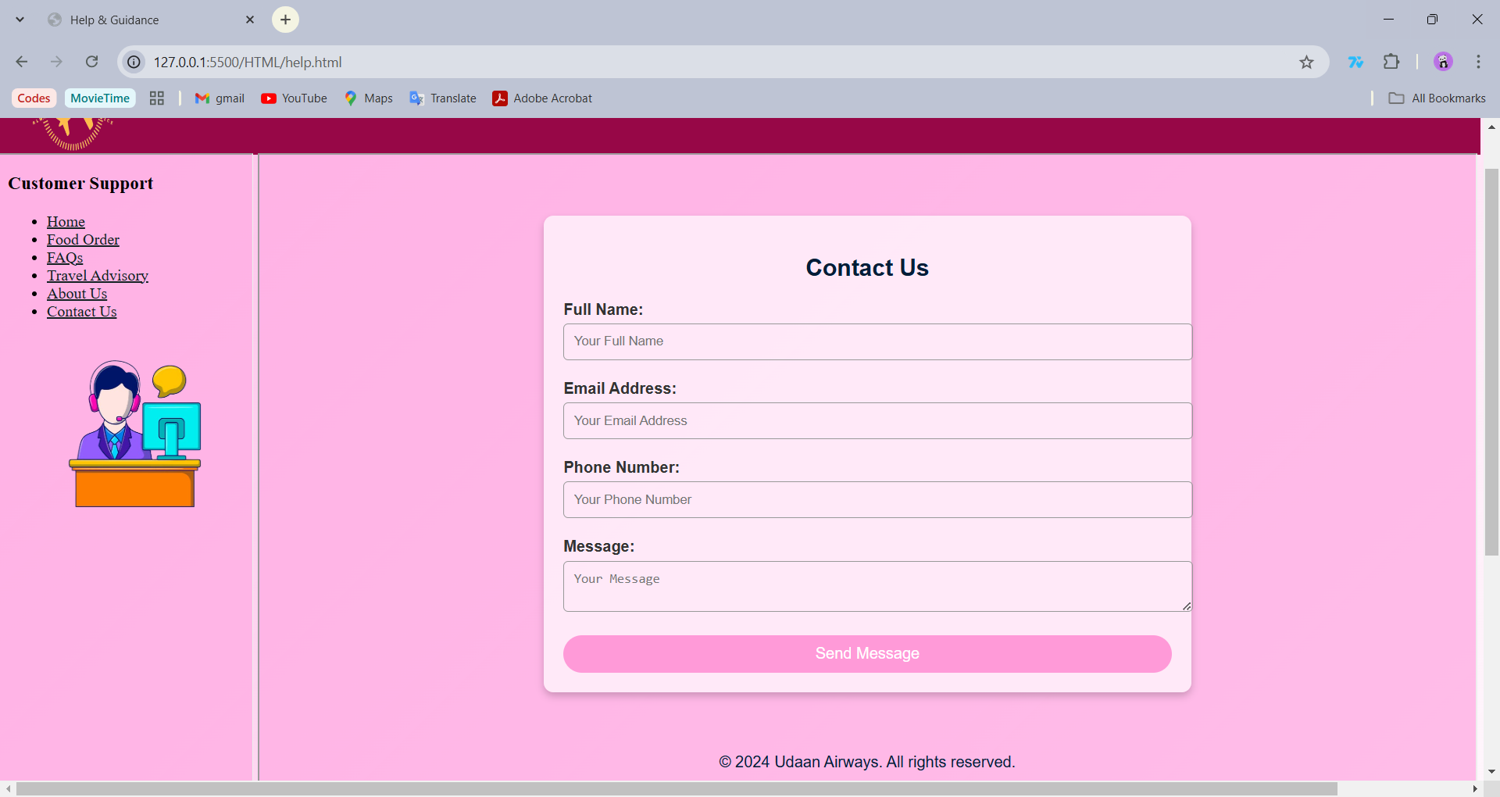

*(Take screen shots of the output at run time and paste it here)*

**B.3 Conclusion:**

**MOHD AMANULLAH SAYYED (C106)-**

*The airline booking website project successfully met all the objectives set at the beginning of the development process. By designing a secure and user-friendly platform, I ensured that users can efficiently register, search for flights, book tickets, and complete payments with ease. The project provided a comprehensive understanding of front-end and back-end development, including the integration of a responsive design that adapts across devices, ensuring a seamless user experience. The secure payment gateway was implemented, guaranteeing safe transactions, while the backend was designed to efficiently manage flight data, user information, and booking details.*

*In terms of learning outcomes, the project allowed me to deepen my knowledge in various web technologies such as HTML, CSS, JavaScript, jQuery, and Bootstrap for database management. I also gained practical experience in implementing key features such as search functionality, flight availability, user registration, and booking management. Furthermore, the experience of designing a real-world solution helped me develop critical problem-solving and technical skills in web development.*

*This project also emphasized the importance of scalability and maintainability in web applications. With a solid foundation in place, the website is ready to be expanded with additional features, such as advanced search filters, loyalty programs, or integration with flight APIs for live data. Overall, the project not only achieved its intended goals but also provided me with valuable hands-on experience in building a fully functional and secure web application.*

*Through this project, I have gained insight into the full development lifecycle, from initial design to final implementation, and have prepared myself for future web development challenges and opportunities.*

*(Students must write the conclusion as per the attainment of individual outcome listed above)*

**B.4 Observations and Learning:**

*In this project, I have gained valuable insights and developed a deeper understanding of various web technologies. Through implementing the design and functionality of an airline booking platform, I learned how to manage complex data systems, integrate user-friendly interfaces, and ensure secure payment gateways.*

*I observed the importance of keeping user experience at the forefront, making sure the platform is intuitive, responsive, and easy to navigate. Additionally, I learned how critical backend systems are in handling data effectively, especially when it comes to managing flight details and user bookings. I also recognized the significance of security in ensuring safe transactions and protecting user information.*

*Furthermore, the project helped me develop problem-solving skills as I faced challenges related to integrating various technologies such as HTML, CSS, JavaScript, jQuery and, Bootstrap . I learned how to overcome these obstacles through research, testing, and implementation, ultimately achieving the project’s objectives.*

*Through this hands-on experience, I also realized the importance of scalability and future-proofing the system to accommodate new features and growing traffic. Overall, this project has not only improved my technical skills but also expanded my understanding of real-world web development challenges and solutions.*

*(Students must write their observations and learnings as per the attainment of individual outcome listed above)*